FaceRankNet: An Interpretable Part-Based Graph Attention Network for Geometry-Driven Facial Beauty Prediction

1stLucky Wijaya
Computer Science Department,
School of Computer Science
Bina Nusantara University
Jakarta, Indonesia 11
lucky.wijaya003@binus.ac.id
4th Dr. Meiliana, S.Kom., M.Sc.
Computer Science Department,
School of Computer Science
Bina Nusantara University
Jakarta, Indonesia 11
meiliana002@binus.ac.id
2nd Gregorius Wilson
Computer Science Department,
School of Computer Science
Bina Nusantara University
Jakarta, Indonesia 11
gregorius.willson@binus.ac.id
3rd Christian Rivaldi
Computer Science Department,
School of Computer Science
Bina Nusantara University
Jakarta, Indonesia 11
christian.rivaldi@binus.ac.id
5th Fiqri Ramadhan Tambunan, S.Kom., M.Kom.
Computer Science Department,
School of Computer Science
Bina Nusantara University
Jakarta, Indonesia 11
fiqri.tambunan001@binus.ac.id

Abstract—Facial beauty prediction (FBP) models based on deep convolutional networks achieve strong benchmark accuracy but offer little insight into which facial regions drive their predictions. We present FaceRankNet, a geometry-only beauty predictor that operates on 3D facial landmark coordinates rather than pixels, partitioning the face into five anatomical organ sub-graphs each scored by an independent graph attention encoder. The five local scores are fused through a learnable softmax, making per-organ aesthetic contributions a direct model output rather than a post-hoc approximation. To supervise the organ encoders without per-region labels, we introduce a weak-supervision signal based on a per-ethnicity beauty-axis projection of the landmark geometry, which we show outperforms distance-based and symmetry-based pseudo-labels by a large margin. On SCUT-FBP5500, FaceRankNet reaches a Pearson correlation of 0.6222 and a mean absolute error of 0.4410, comparable to the geometry-only branch of hybrid models, suggesting a structural ceiling on what landmark coordinates alone can predict. Analysis of the learned organ weights and the score distribution further reveals that a linear averageness prior, while effective near the center of the rating scale, systematically fails to represent highly attractive faces, which perceptual studies show deviate from rather than converge toward the population mean. work.
Keywords—facial beauty prediction, graph attention networks, interpretability, weak supervision, algorithmic fairness, facial landmarks.

Introduction
Facial beauty prediction (FBP) applies machine learning to automate attractiveness assessment, with applications in cosmetic surgery planning, social platforms, and the entertainment industry [1]. Deep CNNs and vision transformers have driven steady accuracy gains on benchmarks such as SCUT-FBP5500 [2] and MEBeauty [3] [4], [5], [6], [7], yet a central limitation persists: these models are difficult to interpret. A pixel-level regressor cannot directly report which facial regions drive its prediction, which is precisely the information that matters in clinical and recommendation contexts [1], [8].
The standard response is post-hoc explanation. Methods such as Grad-CAM [9], SHAP [10], LIME [11], and XRAI [12] reconstruct attributions from a trained model after the fact. Ibrahim, Ugail, and Ugail [8] apply this paradigm to FBP by combining XRAI Region Attribution, permutation importance, and per-region CNNs, converging on the eyes and nose as dominant regions. Notably, their per-region CNNs are trained against the same holistic label rather than a region-specific target, so each head is effectively learning a copy of the global score. These post-hoc pipelines inherit photometric confounds from the pixel regressor they explain.
We take the position, advocated by Rudin [13], that a beauty predictor should be interpretable by design. FaceRankNet operates on 468 MediaPipe 3D landmarks [14], partitions the face into five organ sub-graphs scored by independent graph attention encoders [15], and fuses them through a learnable softmax whose weights are directly readable as per-organ aesthetic importance. The contributions are: (i) a geometry-only, part-based GAT architecture with forward-pass interpretability; (ii) a per-ethnicity beauty-axis pseudo-label that outperforms distance- and symmetry-based alternatives; (iii) a full evaluation on SCUT-FBP5500 including fairness breakdown and ranking-loss ablation; Ease of Use

Related Works

Geometric and Graph Modeling Integration
Early FBP work relied on handcrafted geometric descriptors such as symmetry ratios and inter-landmark distances combined with classical regressors [4], [16], [17], [18], but these were quickly outpaced by pixel-based CNNs. Recent hybrid models bring geometry back via graph neural networks. GeoFusion-Net [19] pairs an EfficientNet-B0 visual branch with a GAT [15] over 86 landmarks and reaches a Pearson correlation of 0.9181 on SCUT-FBP5500. DeepGeoFusion [20] and Peng et al. [21] follow a similar pattern, fusing landmark-derived features with appearance representations. These hybrids confirm that geometry carries aesthetic signals, but each retains a pixel branch that re-introduces photometric confounds (skin tone, lighting, makeup). FaceRankNet discards pixels entirely, trading some accuracy for intrinsic interpretability and reduced demographic dependence.

Weakly Supervised Learning and Pseudo-Labeling via Ranking
The averageness hypothesis, that attractive faces are close to the population mean [16], provides a geometry-only beauty prior without human labels. However, naively using raw distance from an average face as a regression target is fragile, since distance magnitude is dominated by scale and pose noise rather than aesthetic structure. Howlader et al. [25] show in semi-supervised segmentation that rank-statistics similarity to class prototypes is more robust than absolute distance, and use rank-based weights for pseudo-labels. We apply this principle to FBP: instead of raw distance, we project each face onto a learned per-ethnicity beauty axis and percentile-rank the projections, so the pseudo-label reflects relative position along the axis rather than raw magnitude. To inject these pseudo-labels into training, we use a pairwise ranking objective. RankNet [26] turns score pairs into a log-loss over their difference, and R3CNN [27] shows that adding such a ranking subnetwork to a regression head substantially improves FBP correlation on SCUT-FBP5500. FaceRankNet adopts the same loss but applies it per organ using beauty-axis pseudo-scores as the ordering signal.

Methodology
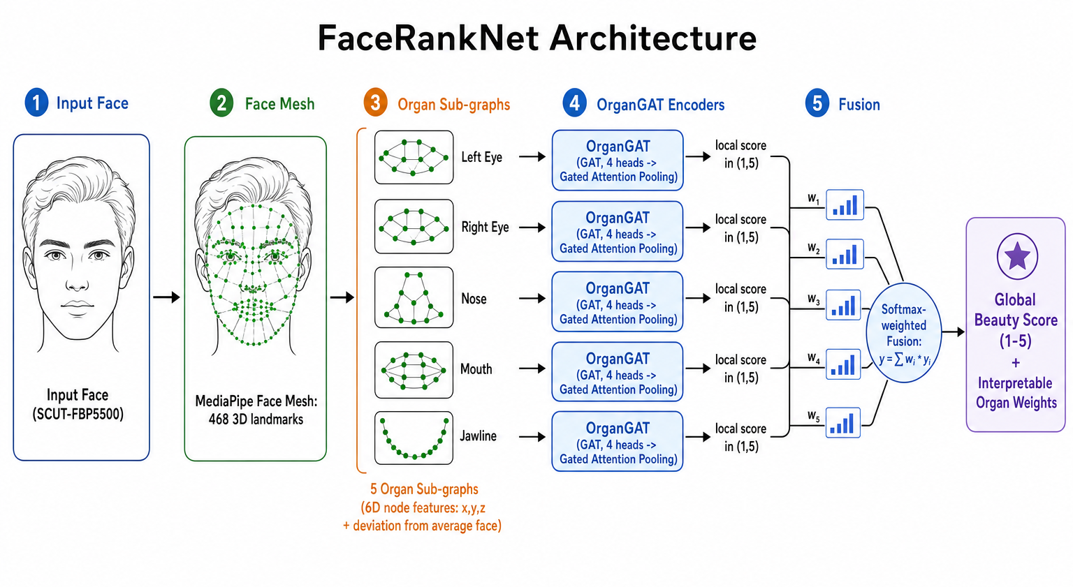
The core idea of FaceRankNet is to score each facial organ independently using graph attention over 3D landmark geometry, and then fuse the resulting local scores into a single global beauty prediction.
- The proposed FaceRankNet architecture. An input face is processed through five stages: landmark extraction, organ sub-graph construction, per-organ encoding via OrganGAT, local score generation, and softmax-weighted fusion into a global beauty score with interpretable organ weights.Dataset, Splits, and Preprocessing

Dataset, Splits, and Preprocessing
We use SCUT-FBP5500 [2], which comprises 5,500 frontal facial images spanning two ethnicities (Asian and Caucasian) and two genders, each annotated with a holistic beauty score in [1, 5] averaged over 60 raters. The ethnicity attribute is derived from the dataset's filename convention. We follow the benchmark's 80/20 train/test protocol (4,400 training and 1,100 test images), and additionally carve a stratified 90/10 train/validation split from the training portion, stratified by rating bucket, yielding 3,960 training, 440 validation, and 1,100 test images. The model checkpoint with the best validation Pearson correlation is selected, and the test set is evaluated exactly once.
Each face is processed with the MediaPipe Face Mesh [14], which returns 468 three-dimensional landmark coordinates with consistent anatomical indexing. We normalize each landmark cloud by centering it on the centroid of all 468 points and dividing by the inter-ocular distance between landmarks 33 and 263 (the outer eye corners), removing translation and scale. Every node then carries a six-dimensional feature vector $\left(x, y, z, Δx, Δy, Δz\right)$, where the first triple is the normalized coordinate and the second triple is the per-node deviation from the Universal Average Face, defined as the mean landmark position over the training set. The deviation channel injects the averageness signal into every node, and the encoder's input projection is correspondingly $\text{Linear}\left(6→64\right)$.
The landmarks are par titioned into five organ sub-graphs: left eye, right eye, nose, mouth, and jawline. The eyebrows are merged into their respective eye sub-graphs, and the two eyes are modeled as two independent sub-graphs rather than one combined region. This asymmetry-tolerant choice is important, because facial asymmetry between the left and right eyes carries aesthetic signal in its own right. Each sub-graph is made fully connected with self-loops so that attention can be computed over all intra-organ landmark pairs.

Weakly Supervised Beauty-Axis Pseudo-Labels
Organ’s pseudo-labels are generate by projecting landmark geometry onto a learned aesthetic direction, computed separately for each ethnicity group $e$. For group$e$, let $μ_{e}$ be the mean landmark configuration over its training faces and $π_{e}$ the mean configuration of its top-30% rated training faces. The beauty axis is the difference vector pointing from the population average toward the attractive end of that group. For each training face $f$ and organ $o$, we restrict $a_{e}$ to the landmark indices of $o$ and compute the scalar projection of the face's organ-local deviation onto that organ-restricted axis:
$$\begin{aligned}p_{f,o} = \frac{\left\langle c_{f,o}-μ_{e,o}, a_{e,o} \right\rangle }{|a_{e,o}|}.\#\left(1\right)\end{aligned}$$
Per-organ projections are then percentile-ranked across the training set and remapped to the rating scale as $s_{f,o}^{\text{psc}}=1+4⋅\text{rank}\left(p_{f,o}\right)∈\left[1,5\right]$. Percentile remapping is the rank-based weighting mechanism we borrow from semi-supervised pseudo-labeling [25]. A face's pseudo-score reflects where it sits along the beauty axis relative to the rest of the training set, rather than the raw magnitude of its projection.

Model Achitechture
The architecture starts by encode the organ is encoded by an independent module called OrganGAT. The six-dimensional node features are first projected into a higher-dimensional space and then processed by a graph attention layer [15] with four attention heads and residual connections, allowing each landmark to selectively attend to other landmarks within the same organ. The outputs of all attention heads are concatenated to form a richer per-node representation, which is then aggregated across all nodes in the organ into a single organ-level embedding using gated attention pooling [30], [31]. A learned gate network assigns a scalar importance weight to each node before pooling, so the pooled embedding reflects which landmarks matter most for that organ's aesthetic score. This organ embedding is then passed through a small two-layer MLP with a dropout layer in between, which maps it down to a single scalar. A sigmoid activation is applied to the output and linearly rescaled so that every local score is guaranteed to fall within the open interval (1, 5).
The five local scores are then fused into a global prediction using a learnable softmax weighting. Each organ is assigned a learnable logit, and the softmax over those logits produces five non-negative weights that sum to one. The global score is the weighted sum of the five local scores, which is mathematically bound to the same (1, 5) interval. Crucially, there is no cross-organ attention and no shared MLP operating over all organs jointly after this point. The fusion is a closed-form convex combination, so the learned weights can be read directly as each organ's relative aesthetic contribution to the final prediction.

Loss Function
The model is trained with a fixed-weight combination of three terms,
$$\begin{aligned}L_{div}=L_{reg}+1.0 L_{rank}+0.01 L_{div}\#\left(2\right)\end{aligned}$$
The anchor regression term is the mean squared error against the holistic rating,
$$\begin{aligned}L_{reg}=\text{MSE}\left(\hat{y_{global}},y_{g}t\right)\#\left(3\right)\end{aligned}$$
The feature-level pairwise ranking term operates per organ and is a margin-masked RankNet-style [26] logistic loss:
$$\begin{aligned}L_{rank}=\frac{1}{\left|\text{kept}\right|}\sum{\left(o\right)\sum{\left(\left(A,B\right)\right){ m}_{o}\left(A,B\right)}\log\left(1+e^{\left(\hat{y_{o}}\left(B\right)-\hat{y_{o}}\left(A\right)\right)}\right)}\#\left(4\right)\end{aligned}$$
where the per-organ pseudo-margin mask $m_{o}\left(A,B\right)$retains only pairs whose beauty-axis pseudo-scores differ by more than $τ$ = 0.3.
The diversity-plus-boundary term spreads the organ scores apart while preventing sigmoid saturation,
$$\begin{aligned}L_{div}=-{\text{Var}}_{o}\left(\hat{y_{o}}\right)+\text{ReLU}\left(1.2-\hat{y_{o}}\right)+\text{ReLU}\left(\hat{y_{o}}-4.8\right)\#\left(5\right)\end{aligned}$$
The variance term encourages distinct per-organ scores rather than five copies of the global score, and the two hinge terms keep local scores away from the boundaries of the open (1, 5) interval, where the sigmoid has vanishing gradient.

Pair Construction, Sampling, and Training
The ranking objective draws on a dedicated pair dataset that is rebuilt every epoch. At pair-construction time we apply a holistic-gap consistency filter that discards any pair whose ground-truth ratings differ by less than 0.5, eliminating near-tie pairs whose ordering is dominated by inter-rater noise. We draw three negatives per anchor and combine two samplers: a weighted sampler with square-root smoothing that rebalances anchor rating buckets so that rare extreme faces appear roughly 3.6 times more often per epoch, and a hard sampler that biases candidate selection toward distant rating buckets so each anchor is contrasted against more extreme faces. To regularize the geometry, we apply landmark jitter augmentation with $σ= 0.003$ after inter-ocular normalization, a perturbation well below the localization error of the landmark detector.
Training uses Adam [32] with learning rate ${10}^{-3}$, weight decay ${10}^{-4}$, batch size 32, and 50 epochs. The framework is PyTorch with the Deep Graph Library [30]. We report global accuracy with the Pearson correlation coefficient (PCC) and mean absolute error (MAE), fairness with the demographic parity difference by subtract MAE Asian and MAE Caucasian.

Experimental Results

Overall Perfomance and Comparison with Prior Work
Table I reports our top-line metrics together with representative SCUT-FBP5500 results from the literature. On the held-out test set, FaceRankNet attains a Pearson correlation of 0.6222, a mean absolute error of 0.4410, and a demographic parity difference of 0.0855.
- Comparison on SCUT-FBP5500.
Method | Input Modality | PCC | MAE
AlexNet [2] | Pixel | 0.8634 | 0.2651
ResNet-18 [2] | Pixel | 0.8513 | 0.2818
ResNeXt-50 [2] | Pixel | 0.8997 | 0.2518
R3CNN [27] | Pixel + ranking | 0.9142 | 0.2120
Dynamic Robust Losses [5] | Pixel + ensemble | 0.9250 | 0.1980
GeoFusion-Net (Attention Fusion)[19] | Pixel + 86-landmark GAT | 0.9181 | 0.2103
DeepGeoFusion [20] | Pixel + 86-landmark GAT | 0.9220 | 0.2022
GeoFusion-Net (GNN) [19] | 86-landmark GAT | 0.6120 | 0.431
KNN [4] | Landmark + handcrafted | 0.7115 | 0.3504
FaceRankNet (ours) | 468-landmark graph | 0.6222 | 0.4410
The comparison is informative on two axes. First, full hybrid models that combine a pixel branch with geometry [5], [19], [27] sit at 0.91 to 0.95 PCC, while pure pixel CNNs reach 0.85 to 0.90 [2]. Second, graph-only baselines that use landmarks alone reach roughly the same plateau as FaceRankNet. GeoFusion-Net's GAT-only branch reports a PCC of 0.612 on the same dataset [19], essentially identical to our 0.6222 despite their use of a different landmark set and graph topology. This convergence is not a coincidence; it suggests a structural ceiling on the aesthetic information that can be extracted solely from landmark coordinates. Human attractiveness is driven by multiple factors that cannot be structurally captured by geometric points, such as skin texture, complexion, lighting, micro-expressions, and hair context. As long as a model only processes the spatial locations of facial points without observing the visual appearance of the regions between them, there remains a performance ceiling that cannot be surpassed merely by refining the graph architecture or increasing model capacity.

Fairness Across Ethinicity
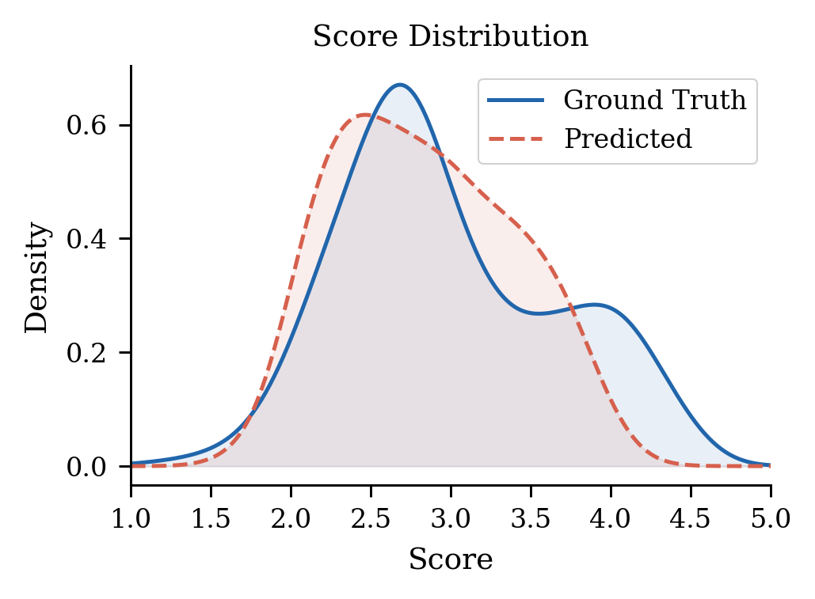
Table II breaks performance down by ethnicity. The per-ethnicity prototype-and-axis design keeps the absolute demographic parity difference small at 0.0855. The Caucasian subgroup, however, is both noisier and less well correlated than the Asian.
- Per-ethnicity comparison on SCUT-FBP5500
Method | Asian |  | Caucasian |  | DPD
 | PCC | MAE | PCC | MAE
FaceRankNet (ours) | 0.6720 | 0.4190 | 0.4540 | 0.5050 | 0.0855
GeomFeat 1 | 0.6705 | 0.3675 | 0.6725 | 0.3615 | 0.0060
GeomFeat 2 | 0.6590 | 0.3810 | 0.6605 | 0.3860 | 0.0050
Geo-Graph | 0.7320 | 0.3615 | 0.7345 | 0.3575 | 0.0040
DeepGeoFusion | 0.9210 | 0.1990 | 0.9210 | 0.2055 | 0.0065

Pseudo-Label Performance
Table III demonstrates that directional beauty-axis methods strongly align with human ratings. The quantile-remapped variant leads with $ρ= 0.577$, over twice the accuracy of distance-based approaches $(ρ= 0.296)$. Conversely, traditional symmetry heuristics correlate negatively ($ρ= -0.160$) and actively degrade performance when used in an ensemble. Consequently, these results validate our proposed directional, per-ethnicity, and percentile-ranked design.
- Pseudo-label generators ranked by global Spearman $ρ$ with human ratings
Generator | Category | Global ρ
Axis (global ethnicity) | Directional | +0.5740
Local axis | Directional | +0.5270
Ensemble (axis + canons + symmetry) | Blend | +0.4300
Canons (proportions) | Rule-based | +0.3500
RMSE (beauty prototype) | Distance | +0.2960
RMSE (population mean) | Distance | -0.1240
Symmetry | Rule-based | -0.1600

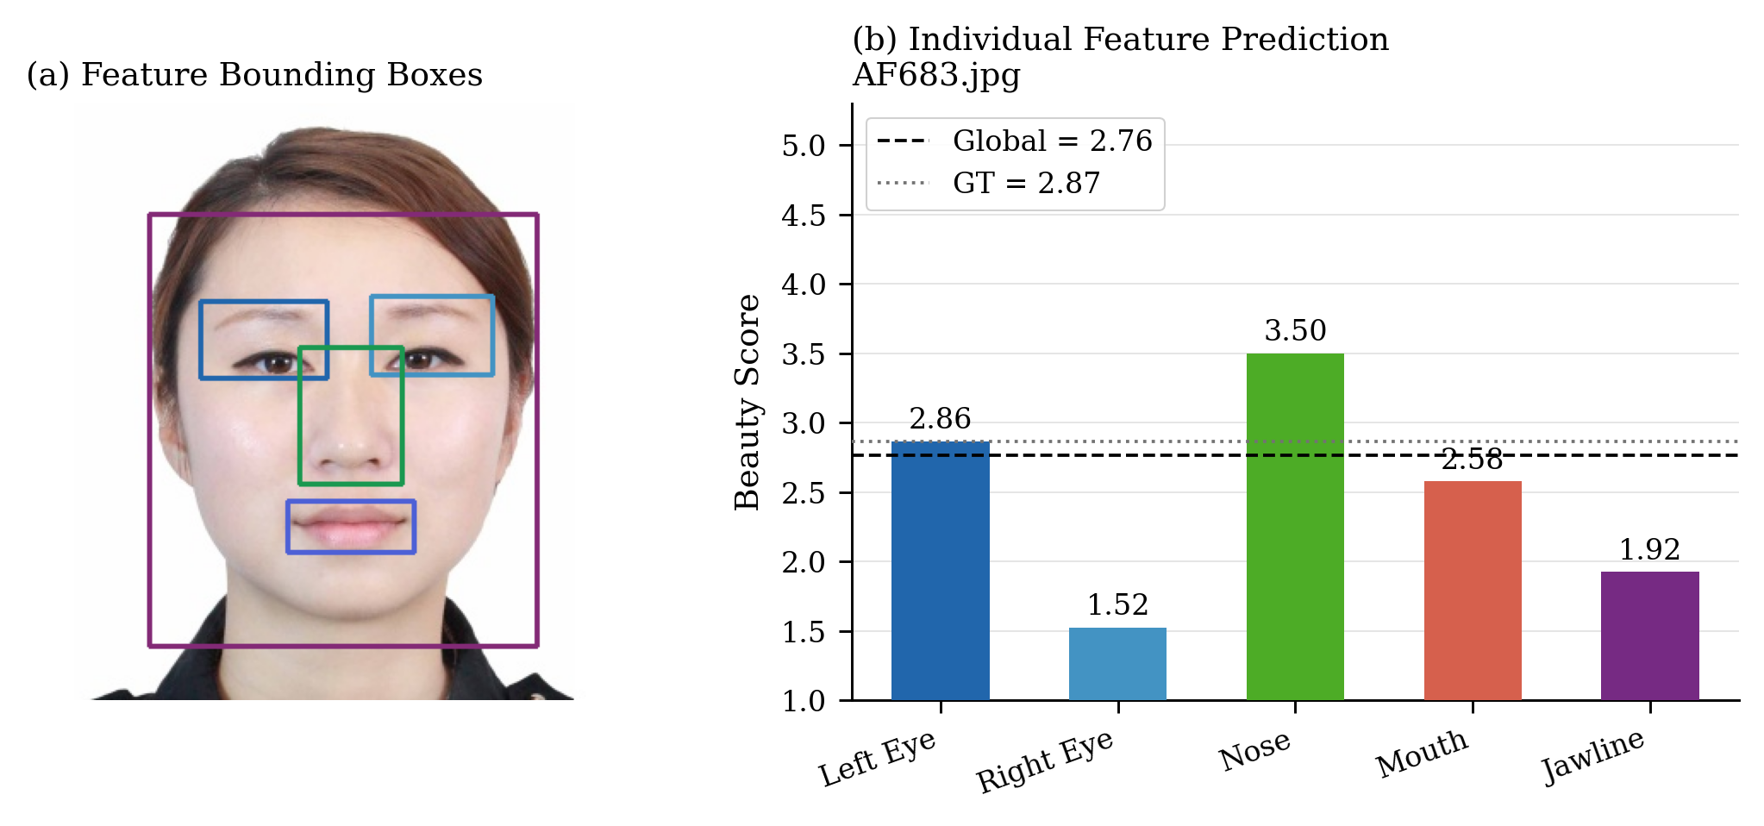
Organ Importance and Local-Score Validity
- Per-organ scores for a representative test face (`viz_AF683.png`). The face has ground-truth rating 2.87 and FaceRankNet global prediction 2.76.
Because fusion is the closed-form softmax the learned weights are an interpretable organ-importance distribution. Fig. 2 shows the per-organ scores for a representative face. The five local scores are clearly distinct from one another and from the global prediction. They are not numerical copies of the global score, which is the primary qualitative evidence that the part-based design yields faithful, per-organ explanations.
- Kernel density estimates of predicted versus ground-truth scores on the test set.
The KDE plot comparing predicted and ground-truth score distributions highlights a systematic compression effect. The predicted distribution is notably narrower than the ground truth; specifically, the model rarely predicts scores above 4.3, despite the test set containing 126 faces rated $≥4$. This regression-to-the-mean phenomenon represents the primary source of prediction error.

Discussion

The Role of Ranking Loss
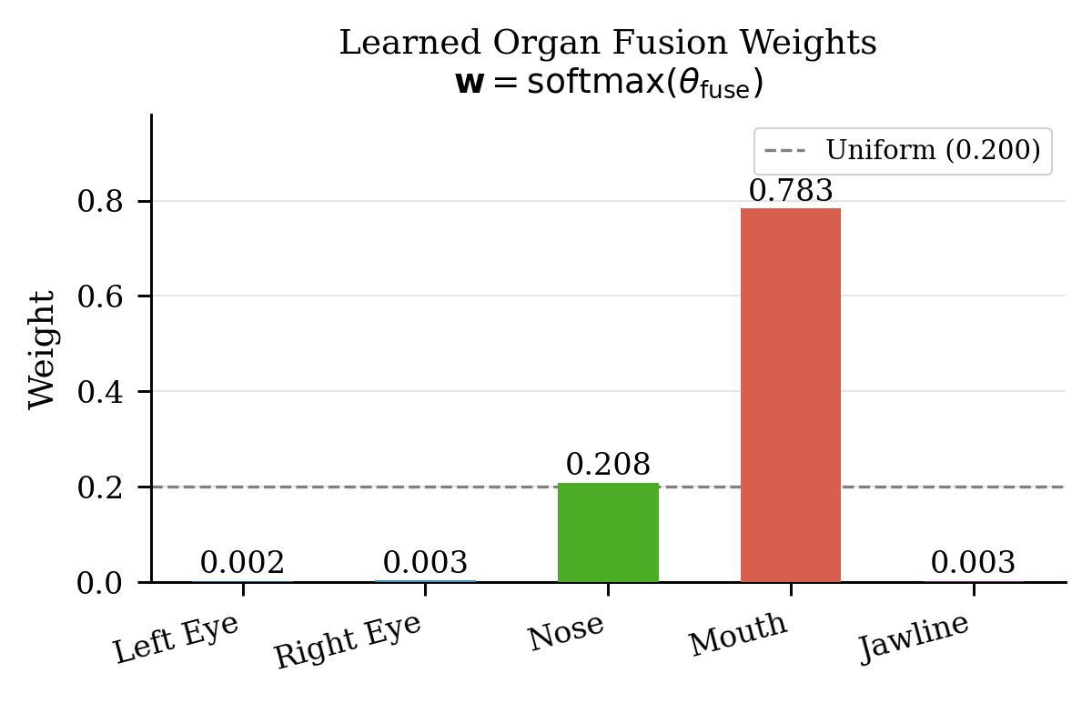
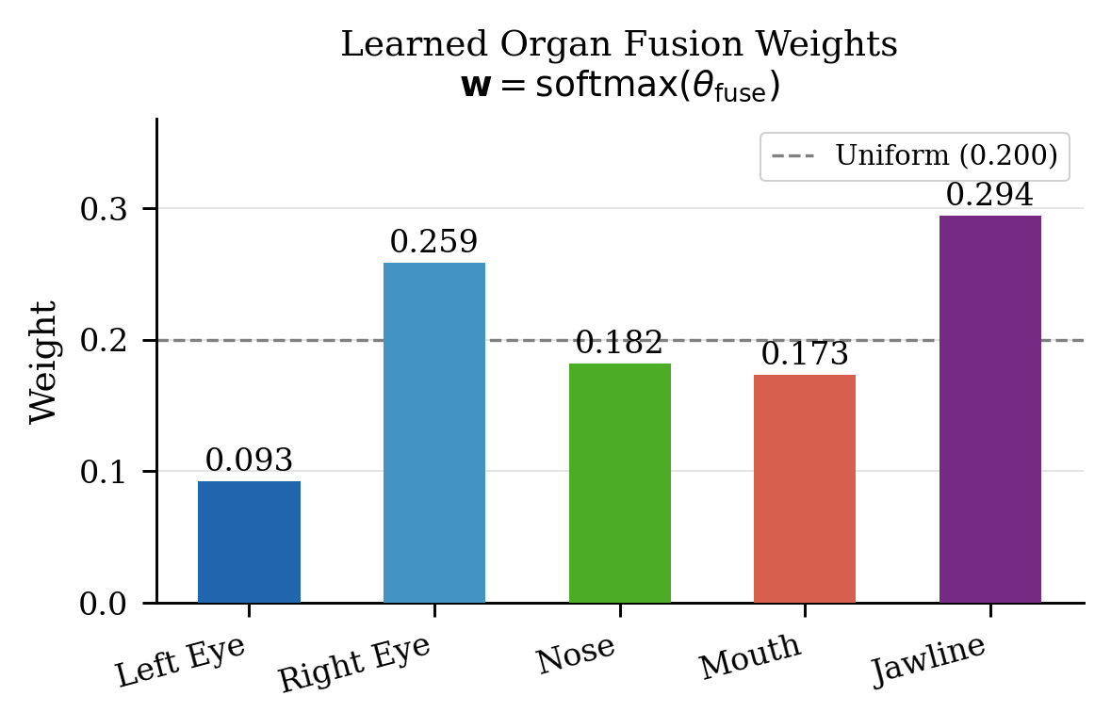
The ranking loss $L_{rank}$ (Eq. 3) is the most consequential single term in the loss function, and ablating it reveals a clear trade-off between the fusion-weight distribution and the health of the per-organ encoders. Fig. 4 shows the learned softmax fusion weights for the two regimes
- Learned organ fusion weights With $L_{rank}$enabled: weights collapse onto a single dominant organ, Without $L_{rank}$: weights spread more uniformly across all five organs.
The With $L_{rank}$ enabled, the softmax fusion weights become highly concentrated. The model heavily relies on the mouth (0.78) and the nose (0.21), while virtually ignoring the other organs. However, despite this imbalance, the underlying per-organ scores remain healthy and distinct. As shown in Fig. 2, the nose scores 3.50, the mouth 2.58, and the left eye 2.86, all sitting comfortably within the valid scale. The pairwise ranking term forces every organ encoder to actively learn aesthetic signals, ensuring that each part still provides meaningful beauty scores even if the global fusion head prioritizes only a few.
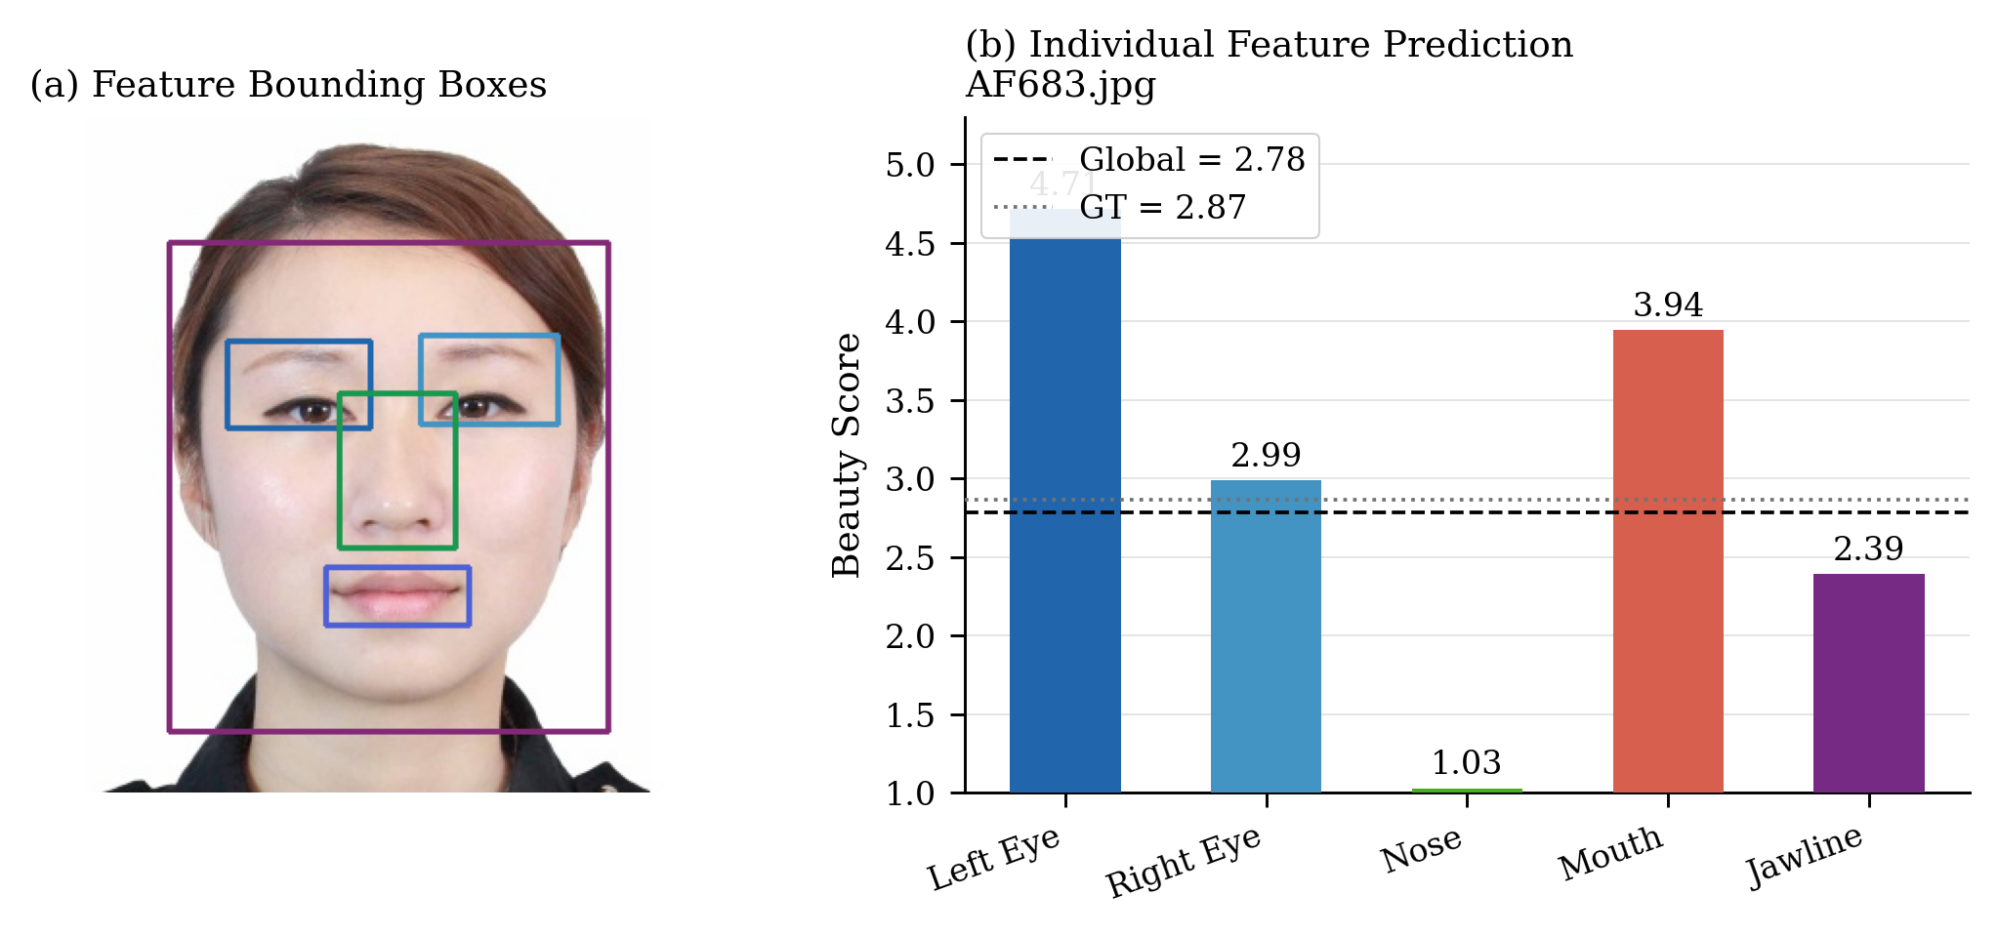
Without $L_{rank}$, the situation completely inverts. The fusion weights appear much more balanced across all organs (Fig. 4), which might initially seem like a good thing. Unfortunately, inspecting the actual per-organ scores reveals a critical failure. As shown in Fig. 5 and Fig. 6, the nose encoder completely collapses to its lower limit of 1.0, while the left-eye encoder saturates at its maximum upper bound across almost all test faces. In reality, the "balanced" fusion weights are just a mathematical trick to compensate for these collapsed scores. The model loses its ability to grade each facial part individually, rendering the local scores meaningless.

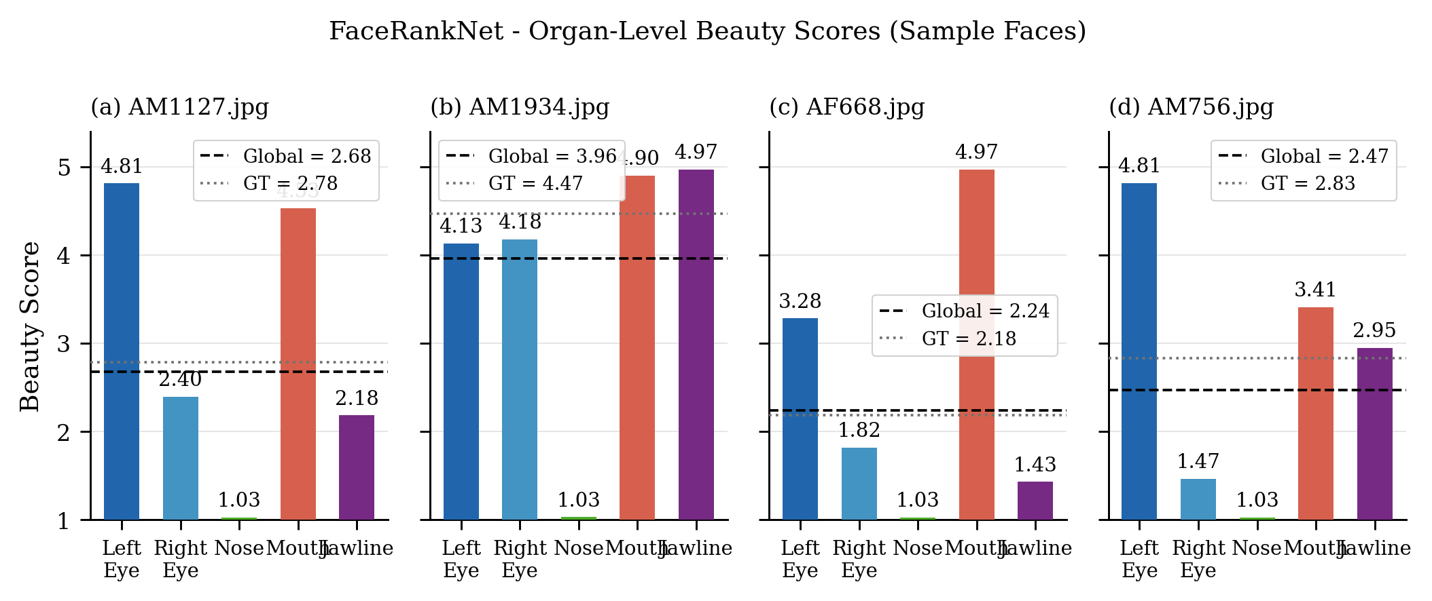
- Re-evalutate organ score for test face (`viz_AF683.png`) with ranking loss.
- Learned organ fusion weights With $L_{rank}$enabled: weights collapse onto a single dominant organ, Without $L_{rank}$: weights spread more uniformly across all five organs.
Varied fusion weights do not guarantee true interpretability. Without our ranking loss, a model can easily fake this diversity by collapsing all organ scores into a single global value. $L_{rank}$ prevents this issue. Although it makes the final model mouth-dominant, it forces the network to learn real, distinct signals for every organ. As shown in Fig. 2, these individual organ scores are what give practitioners clear, actionable insights into how the model evaluates beauty.

Fairness and the Per-Ethnicity Beauty Axis
While geometry-based baselines consistently achieve low DPD values (0.004–0.007) by discarding biased photometric cues, FaceRankNet records a higher DPD of 0.0855. This fairness gap stems from our per-ethnicity supervision mechanism rather than the input modality. By estimating separate beauty axes for Asian (n=822) and Caucasian (n=278) groups, the pseudo-labels explicitly encode demographic boundaries. The heavily imbalanced Caucasian sample produces a noisier aesthetic prototype, degrading its specific prediction quality and artificially inflating the DPD. Consequently, although the per-ethnicity design correctly accounts for distinct cultural aesthetic norms [13], [33], it inadvertently introduces a sample-size sensitivity that group-agnostic baselines completely avoid.

Regression to the Mean and the Limits of a Linear Averageness Prior
We The KDE in Fig. 3 makes plain that FaceRankNet under-predicts the high-score tail and over-predicts the low-score tail, the canonical signature of regression to the mean. This pattern is amplified by the visible under-training in our learning curves, but it is not merely a training artifact. It reflects a more fundamental limitation of the pseudo-label design. The beauty axis is a single linear direction from the population mean toward an attractive prototype, which means the pseudo-label signal is strongest for faces near the center of the distribution and weakest for faces at the extremes. This is a direct consequence of treating attractiveness as proximity to an average, which the perceptual literature has shown to be an incomplete account. Perrett, May, and Yoshikawa [23] demonstrated that highly attractive composite faces are mathematically less average than the population mean, and that exaggerating features away from the mean in the direction of the attractive prototype actually increases perceived attractiveness. DeBruine et al. [24] confirmed across five experiments that attractiveness and averageness are dissociable: the most attractive faces occupy a specific direction in shape space, not the population centroid. Our beauty-axis formulation captures this direction, which is why it substantially outperforms RMSE-from-average pseudo-labels in Table III, but a single linear axis cannot represent the non-linear geometry of the high-attractiveness region. The residual compression at the rating extremes is the empirical signature of this gap.

Conclusion
We presented FaceRankNet, an interpretable part-based graph attention network that predicts facial beauty from landmark geometry rather than pixels. By scoring five anatomical organ sub-graphs independently and fusing them through a learnable softmax, the model produces a global beauty prediction together with a per-organ aesthetic contribution as a first-class output. On SCUT-FBP5500 it reaches a test Pearson correlation of 0.6222, MAE 0.4410, and DPD 0.0855, and its learned organ weights echo, but do not exactly duplicate, the eyes-and-nose consensus of prior post-hoc interpretability studies [8]. A weak-supervision signal based on a per-ethnicity, percentile-ranked beauty-axis projection proved decisively stronger than distance- and symmetry-based alternatives.
Two limitations define the boundary of the current model and point directly to future work. First, a geometry-only approach is insufficient for state-of-the-art FBP accuracy. Our 0.62 PCC is essentially identical to the GAT-only branch of GeoFusion-Net [19] (0.612) on the same dataset, while full hybrid models that retain a pixel branch sit at 0.91 to 0.95 [4], [5], [19], [27]. The gap reflects a structural ceiling: skin texture, complexion, hair, and lighting context all carry aesthetic signal that 468 landmark coordinates cannot encode. Additionally, the per-ethnicity beauty axis is sensitive to training set size per group, as the smaller Caucasian subset (278 vs. 822 Asian samples) produces a less reliable prototype that inflates DPD. Expanding training data with more balanced multi-ethnic benchmarks such as MEBeauty [3] is a direct remedy and would also allow the per-ethnicity axis mechanism to be evaluated under more equal group representation. One natural extension is a dual-graph architecture in which each organ sub-graph is paired with a texture encoder operating on the corresponding facial crop, preserving the per-organ interpretable structure while recovering the photometric signal the current model cannot access. Second, the linear beauty-axis pseudo-label fails at the rating extremes because attractive faces do not simply lie closer to the population mean [23], [24]. Two directions address this directly. The hard binary pseudo-margin mask in Eq. (4) could be replaced with a continuous weight based on the rank-statistics similarity [25] between each face's latent features and an ideal beauty prototype, giving more gradient to pairs in the upper tail where the current hard margin provides the least training signal. Alternatively, moving from single-scalar pseudo-labels to a distribution over the rating scale would give the OrganGAT encoders richer supervision at the extremes, consistent with how the SCUT-FBP5500 labels were collected from 60 raters and with prior work showing that distribution targets improve tail calibration in pixel-based FBP models [7].

Reference
- A. H. Ibrahem and A. M. Abdulazeez, "A comprehensive review of facial beauty prediction using multi-task learning and facial attributes," ARO-The Scientific Journal of Koya University, vol. 13, no. 1, pp. 10–21, Feb. 2025.
- L. Liang, L. Lin, L. Jin, D. Xie, and M. Li, "SCUT-FBP5500: A diverse benchmark dataset for multi-paradigm facial beauty prediction," in Proc. 24th Int. Conf. Pattern Recognition (ICPR), Beijing, China, 2018, pp. 1598–1603.
- I. Lebedeva, Y. Guo, and F. Ying, "MEBeauty: A multi-ethnic facial beauty dataset in-the-wild," Neural Computing and Applications, vol. 34, pp. 1–15, 2022.
- T. J. Iyer, K. Rahul, R. Nersisson, Z. Zhuang, A. N. Joseph Raj, and I. Refayee, "Machine learning-based facial beauty prediction and analysis of frontal facial images using facial landmarks and traditional image descriptors," Computational Intelligence and Neuroscience, vol. 2021, art. 4423407, 2021.
- F. Bougourzi, F. Dornaika, and A. Taleb-Ahmed, "Deep learning based face beauty prediction via dynamic robust losses and ensemble regression," Knowledge-Based Systems, vol. 242, art. 108246, 2022.
- D. E. Boukhari, A. Chemsa, and R. Ajgou, "Facial beauty prediction based on vision transformer," International Journal of Electrical and Electronic Engineering & Telecommunications, 2023.
- A. A. Ibrahim, N. H. Ugail, T. H. Jayatileke, M. H. Saffery, and H. Ugail, "Facial beauty analysis using distribution prediction and CNN ensembles," in Proc. 15th Int. Conf. Software, Knowledge, Information Management and Applications (SKIMA), 2023, pp. 130–135.
- A. A. Ibrahim, N. H. Ugail, and H. Ugail, "Is facial beauty in the eyes? A multi-method approach to interpreting facial beauty prediction in machine learning models," Discover Artificial Intelligence, vol. 5, no. 1, art. 16, Dec. 2025.
- R. R. Selvaraju, M. Cogswell, A. Das, R. Vedantam, D. Parikh, and D. Batra, "Grad-CAM: Visual explanations from deep networks via gradient-based localization," Int. J. Computer Vision, 2019.
- S. M. Lundberg and S.-I. Lee, "A unified approach to interpreting model predictions," in Advances in Neural Information Processing Systems (NeurIPS), vol. 30, 2017.
- M. T. Ribeiro, S. Singh, and C. Guestrin, "'Why should I trust you?': Explaining the predictions of any classifier," in Proc. 22nd ACM SIGKDD Int. Conf. Knowledge Discovery and Data Mining, 2016, pp. 1135–1144.
- A. Kapishnikov, T. Bolukbasi, F. Viégas, and M. Terry, "XRAI: Better attributions through regions," arXiv preprint arXiv:1906.02825, Aug. 2019.
- C. Rudin, "Stop explaining black box machine learning models for high stakes decisions and use interpretable models instead," Nature Machine Intelligence, vol. 1, no. 5, pp. 206–215, 2019.
- Y. Kartynnik, A. Ablavatski, I. Grishchenko, and M. Grundmann, "Real-time facial surface geometry from monocular video on mobile GPUs," arXiv preprint arXiv:1907.06724, 2019.
- P. Veličković, G. Cucurull, A. Casanova, A. Romero, P. Liò, and Y. Bengio, "Graph attention networks," in Proc. Int. Conf. Learning Representations (ICLR), 2018.
- J. H. Langlois and L. A. Roggman, "Attractive faces are only average," Psychological Science, vol. 1, no. 2, pp. 115–121, 1990.
- G. Rhodes, F. Proffitt, J. M. Grady, and A. Sumich, "Facial symmetry and the perception of beauty," Psychonomic Bulletin & Review, vol. 5, no. 4, pp. 659–669, 1998.
- T. Peng, M. Li, F. Chen, Y. Xu, and D. Zhang, "Geometric prior guided hybrid deep neural network for facial beauty analysis," CAAI Trans. Intelligence Technology, vol. 9, no. 2, pp. 467–480, 2024.
- D. E. Boukhari and M. Kezai, "GeoFusion-Net: A hybrid graph and convolutional network for facial beauty prediction," in Proc. IEEE Int. Conf. (in press), 2025.
- K. Wang, Y. Li, D. Huang, J. Feng, and X. Feng, "DeepGeoFusion: Personalized facial beauty prediction through geometric-visual fusion," Frontiers in Computer Science, vol. 7, Jan. 2026.
- Y. Zhai, Y. Huang, Y. Xu, J. Gan, H. Cao, W. Deng, R. D. Labati, V. Piuri, and F. Scotti, "Asian female facial beauty prediction using deep neural networks via transfer learning and multi-channel feature fusion," IEEE Access, vol. 8, pp. 56892–56907, 2020.
- A. Sisti, N. Aryan, and P. Sadeghi, "What is beauty?" Aesthetic Plastic Surgery, vol. 45, no. 5, pp. 2163–2176, 2021.
- D. I. Perrett, K. A. May, and S. Yoshikawa, "Facial shape and judgements of female attractiveness," Nature, vol. 368, no. 6468, pp. 239–242, Mar. 1994.
- L. M. DeBruine, B. C. Jones, L. Unger, A. C. Little, and D. R. Feinberg, "Dissociating averageness and attractiveness: Attractive faces are not always average," Journal of Experimental Psychology: Human Perception and Performance, vol. 33, no. 6, pp. 1420–1430, Dec. 2007.
- P. Howlader, H. Le, and D. Samaras, "Weighting pseudo-labels via high-activation feature index similarity and object detection for semi-supervised segmentation," arXiv preprint arXiv:2407.12630, Jul. 2024.
- C. Burges, T. Shaked, E. Renshaw, A. Lazier, M. Deeds, N. Hamilton, and G. Hullender, "Learning to rank using gradient descent," in Proc. 22nd Int. Conf. Machine Learning (ICML), 2005, pp. 89–96.
- L. Lin, L. Liang, and L. Jin, "Regression guided by relative ranking using convolutional neural network (R3CNN) for facial beauty prediction," IEEE Trans. Affective Computing, vol. 13, no. 1, pp. 122–134, 2019.
- R. G. Praveen, P. Cardinal, and E. Granger, "Weakly supervised learning for facial affective behavior analysis: A review," arXiv preprint arXiv:2101.09858, Mar. 2026.
- X. Wang, X. Hou, M. Ding, J. Chen, K. Deng, J. Xie, and L. Shen, "DisFaceRep: Representation disentanglement for co-occurring facial components in weakly supervised face parsing," in Proc. 33rd ACM Int. Conf. Multimedia (MM '25), Oct. 2025, pp. 4020–4029.
- M. Wang, D. Zheng, Z. Ye, Q. Gan, M. Li, X. Song, J. Zhou, C. Ma, L. Yu, Y. Gai, T. Xiao, T. He, G. Karypis, J. Li, and Z. Zhang, "Deep graph library: A graph-centric, highly-performant package for graph neural networks," arXiv preprint arXiv:1909.01315, 2019.
- Y. Li, D. Tarlow, M. Brockschmidt, and R. Zemel, "Gated graph sequence neural networks," in Proc. Int. Conf. Learning Representations (ICLR), 2016.
- D. P. Kingma and J. Ba, "Adam: A method for stochastic optimization," in Proc. Int. Conf. Learning Representations (ICLR), 2015.
- J. Zhan, M. Liu, O. G. B. Garrod, C. Daube, R. A. A. Ince, R. E. Jack, and P. G. Schyns, "Modeling individual preferences reveals that face beauty is not universally perceived across cultures," Current Biology, vol. 31, no. 10, pp. 2243–2252, 2021

